Hi,
This may serve as a manual of sorts for the demo called the “AIAlerts” database. Please keep in mind this is really just a technology and concept demonstrator. It is meant to facilitate discussion about what you might actually want. It is meant to be very crudely functional, but only in the crudest sense.
General Project Requirements:
1: The read Amnesty International reports as PDF’s and parse the “Torture and Other Ill-Treatment” sections out of them.
2: To put the sections into a database.
3: To allow the creation of (about three) entries that describe the torture that happened.
Progress
A program was written, called a parser, that parsed Amnesty Reports from 2013-2008. It created a file for each year that has the “Torture and Other Ill-Treatment” sections in it. These files have been saved on the internet. More on that later.
A website was created that has a database that can serve requirements #2 and #3. The website is very, very crude.
Quick Start Guide:

1: Get the “extract files” that where created in requirement #1 onto your local drive.
a: open https://github.com/pdfliberation/amnestydata/releases in your browser.
b: Notice the Green blocks labelled “2013.torture.extract.json” as well as the other years. These files are in JSON format. JSON stands for JavaScript Object Notation. Click on the “2013.torture.extract.json” file and it will save locally. Feel free to do this with the other files as well.
2: Open one of the files SON with notepad or other text editor. You will see an entry for each country for whatever year the file is for. This is just so you will know what is in the file. No other reason. Close the file. It’s probably not a good idea to save changes or edit the file.
3: Go to the AIAlerts website at http://aialerts.herokuapp.com/ (also http://aialerts.heroku.com will work). **** NOTE: that the application may have been put into idle mode, so it could take 10 or 15 seconds to start up when you first open the link ****
4: Notice the four main functions on the website “home” page.
A: Add, inspect and delete on the “alerts” page. You don’t need to go there yet.
B: The RESTFul API at the “widgets” page.
C: The Upload bulk data at the “uploads” page.
D: The Use RESTful API to save bulk data, which has three links.
Also notice the large, underlined “Amnesty International Alerts Database” on the top of the page. This is a link that is on all the pages that will take you back to this “home” page.
5: Click on the “Alerts” page link. This is where the database is. As I have left it, there are 5 entries for ALBANIA for 2013. I uploaded the first entry, the large one, and I created the other four. On the other four, the short ones, there are entries in the “Method” and the “Agency” fields. I put them there manually.
6: Create a manual entry yourself. Highlight a small section of the text on the large entry in the first row of the blue table, preferably a sentence that isn’t in one of the other four rows. This is the idea. The idea is that someone will take the large sections and manually break them into smaller sections. When you do that, then you can put entries into the “Method” and “Agency” fields. For example:
A: highlight the last sentence of the text of the first row (of the blue table) , which is “The Ombudsperson considered the actions of theTirana police in denying hunger strikers medicines and liquids to be an act of torture.” Right click and select “copy.” Go to the very top, and paste the sentence into the Description field of the Orange table. The orange table is the one with the “Add” buttons. Fix the text if you want to. Then, add entries into the other fields. In the country field, put “ALBANIA”. In the Date field put “2013”. In the Method field put “Denied Medicine”. In the agency field put “Tirana Police”. Now click the Add button. You will see a new row appear at the bottom of the blue table.
7: Save your work. Click on the “Amnesty International Alerts Database” link at the top of the screen. It will go back to the “home” page. Click on the link that says “All data = http://aialerts.herokuapp.com/data”. Depending on what browser you are using this will either ask you to save a “data.json” file or show you the JSON file on the screen. If you save it, then open it in notepad or something like you did in step #2. If it shows up on the screen, then right click the screen and select “save as”. This will allow you to save your work on the local drive. When you open the file you have saved, you will see the row that you created as well as all the other rows.
8: click the back button, if you need to, and get back to the “home” page.
9: Go back to the “alerts” page.
10: Delete the row you created. In fact, delete all the rows. It is ok, you saved them when you saved the file in step #7.
11: Reload your data. Click on the “Amnesty International Alerts Database” link at the top of the screen. Click on the “uploads” link. You will see the ugliest uploads page ever. Click on the “browse” button and find and open data.json (or whatever you called it) file that you just saved. After that, click on the “upload” button. You have probably done this sort of thing before.
12: At this point your work will be restored. There should be all the rows there were there when you saved the data, the large row, and the four parsed out sections that were created manually.
13: This describes the manual process of creating information from the reports. Manually you take the individual reports that were parsed from a country and create a new rows that have the extra fields filled out manually. The presumed requirement is that this new data will be used for some sort of analysis.
14: Complete this exercise by parsing all of the sentences out of the ALBANIA main text section. Once you are done, delete the main section so that only the subsections remain.
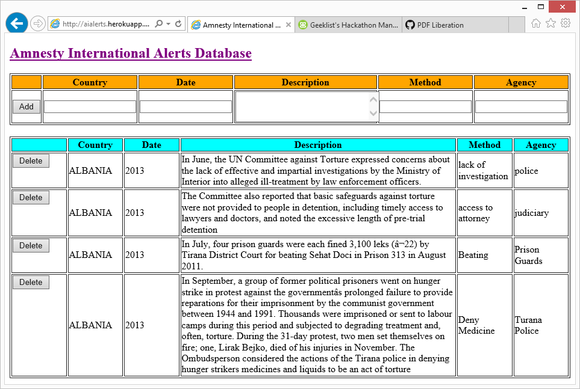

15: Now you can work on the real data. Delete all of the rows in the database. Go to the upload page and load one of the full year files that you saved in step 1. Break all of the country’s entries into separate entries that have the information that can be analyzed. Be sure to save your work periodically.

Comments on the Above Process
Again, this is only a concept to see if this is what Amnesty actually wants to do. There are many issues with the above approach. The first most obvious is that there is only one database. If more than one person attempts to edit at the same time it could be a little strange. It should work, but you will see other people’s work added (or deleted) every time you click a button or refresh the screen. Two people trying to work on the same country from different websites would be a problem.
The API interface could be used to read the data by other programs. For example, if someone was working on auto-detecting and splitting the individual country entries into new rows they could get data from the API. The API could be expanded to do inserts, which would have more flexibility than the “upload” page. Something to think about.
The size of the 2013.torture.extract.json files is pretty large. They are not physically very large, but when you load them into the website you get a lot of rows. One for each county and there is at least 100 or so. If you broke those into individual rows, there could be as much as a thousand rows. Displaying that on one webpage is not very helpful. This is why the site is only a technology demonstrator.
Amnesty needs to make their own goals clear, which is something that needs further work at this point. Do they plan on doing analysis? Do they plan on creating an internal database? Isn’t there one already? Do they want to create an API portal so that others can help by displaying torture alerts? This project was put together to show what is possible, but it is a very crude website.

The PDF’s were parsed and the “Torture and other Ill-Treatment” sections were saved to files. We have only gotten as far back as 2008 at this point, but I just haven’t tried running the code for early Amnesty Int. files yet. I may be able to try it later, but right now I have to get back to my other life for a bit. At this point you guys will need to digest what has been done and play around with it. Let me elaborate.
The site is a simple database. The database only holds country, date, and description, plus two ‘extra fields.’ The two extra fields are blank, and they are labeled ‘method’ and ‘agency.’ The expectation, but what I envisioned, was that the descriptions that were uploaded would be cut-and-pasted into new, multiple entries with the two extra fields filled out. As we discussed, this will have to be done manually.
The site supports saving and uploading the data. When you click on the ‘RESTful bulk data’ links the program will send you a file that is a ‘JSON’ file. It is the same format that the parsers created, and is an internet standard format. You can then ‘save’ the ay manual work that was done. You could also re-upload it later if need be.
Currently, I only uploaded the 2013 file. It had a lot of entries. I envisioned your team working on one year at a time. After splitting each section into multiple sections with the statistical fields filled out, you would then save the file, delete all the records, and upload another year and work on that.
Have a look, it will make more sense once you’ve had a chance to play around a bit.

Secondly, we talked about an ‘alerts database’ for other sites to use. The data functions can also serve that purpose. There is an example of a script that another site would put into their page to show an alert. I made it as simple as possible for demonstration purposes. My understanding is it would need to be made more robust, with some additional features such as authentication and cross-site scripting support before it would be production ready. But it shows the idea.
The site that is hosting the database/pages is heroku.com. They give a free site, but it has a limit of 750 dyno’s a month. I have no idea what that means J , but you may well run into the limit if you start using the site seriously. The dyno’s can easily be increased if you give them your credit card, but I’m not sure how much they need. I wouldn’t worry about running out at this time, and I can check how many dyno’s have been used anytime you want. The heroku free site seems kind of slow to me, so any slowness you experience is probably coming from them, not the code.

